Name | Priyanka H. Dhakate
Class | SY IT(A)
PRN | 124B1F145
Batch | A4

-: Assignment 6: -
Write all types of Database Triggers for suitable application.
- Without Delimiter:-
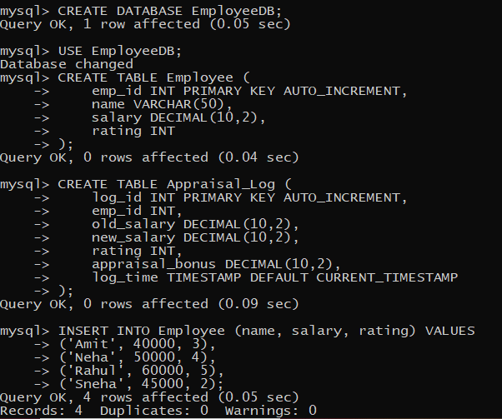

- Insert trigger
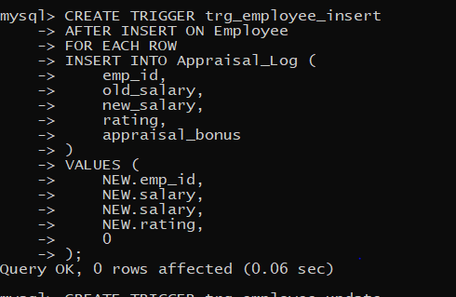

- Update trigger
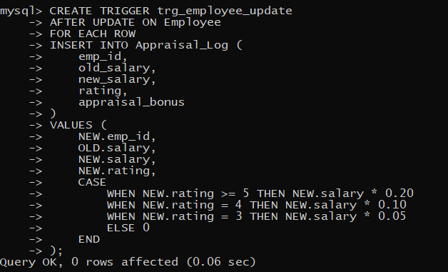
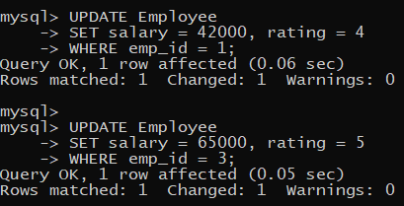
- Delete trigger
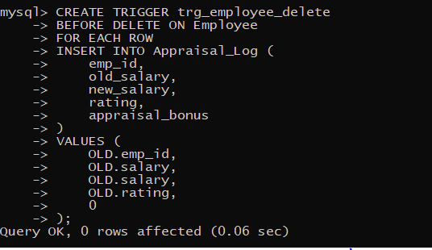
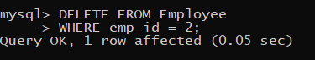

- Display result
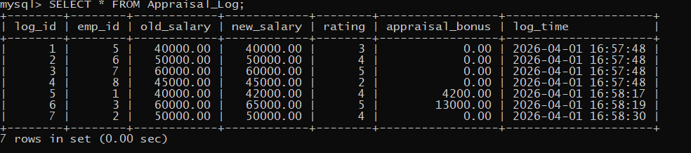

- WITH DELIMITER: -

- Insert trigger
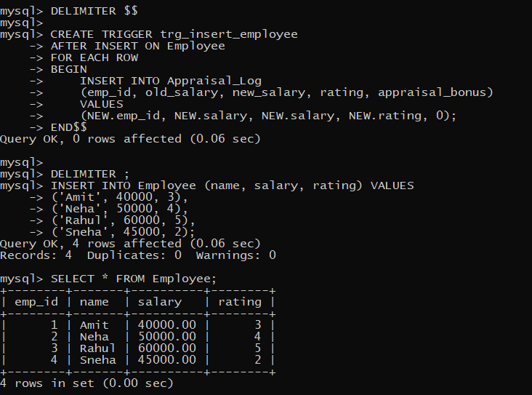

- Update trigger
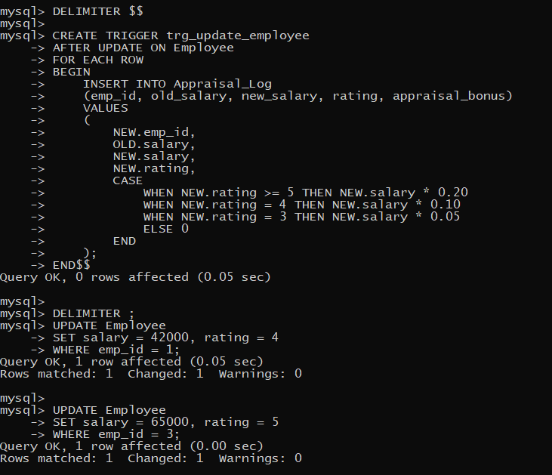

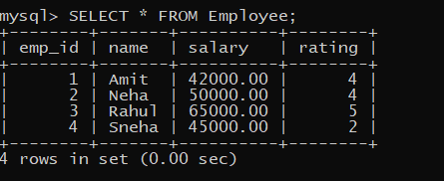

- Delete trigger
